

COLLEGE OF AERONAUTICS AND ENGINEERINGKENT STATE UNIVERSITY

LINEAR SYSTEM ANALYSIS AND CONTROL

PROFESSOR: DR.TAO SHEN BONUS PROJECT REPORT

ANAND

KSU 811310534

[anand@kent.edu](mailto:anand@kent.edu)

ROHITH KUMAR KANCHUGATLA

KSU 811229942

[rkanchug@kent.edu](mailto:rkanchug@kent.edu)

CONTENTS

1. Abstract
2. Introduction
3. Derive Transform Function
4. Derive State Space Equation
5. Stability
6. Controllability
7. Observability
8. Design a Feedback gain for a closed loop control
9. Conclusion
10. Abstract

The process of designing a suspension system for a car involved simplifying the model for one set of tires into a mass-spring-damper system. This simplification was achieved through the utilization of Simulink, transfer function analysis, and the state-space method.

1. Introduction:

In this modelling and controlling one quart of a car suspension. Should roads be smooth and even, suspensions would not need to exist. That is just the case; roads have bumps and holes that make tires loose contact with the

ground, therefore loosing friction, stability and steering capability. When a wheel passes over an imperfection, it experiences a vertical acceleration. The suspension will absorb that energy, minimizing vibration and creating a comfort sensation for passengers. Lately, demands for improved ride comfort and controllability of vehicles, and high availability of electronic systems, has motivated the development of active and semi active suspension systems.

# 3.0 Derive Transform Function

spring produces a force proportional to displacement, the viscous damper produces a force proportional to the position´s first derivative and the mass produces a force proportional to the position´s second derivative, the system is modelled as particles shows, in a free body diagram (FBD), the acting forces in ms. The balance of forces for mt is shown in FBD which summarizes its movement.

ms = 250 kg

Ks = 18.600 N/m

bs = 1000 Ns/m mt = 50 kg

Kt = 196.000 N/m Fa=1500 N

The system´s transfer function (TF) was calculated from Newton´s second law,

Where are f(t), Applying Laplace transform,

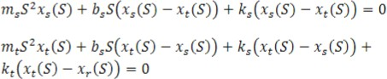

# Derive State Space Equation

Because there are four energy accumulators in the suspension (m s, m t, ks and kt), the system has four state variables. These are the variables that describe the system´s energy. Where the first following two are potential and last two represent kinetic energy.

X1 = Xs Vert. displacement of the car (m s) X2 =Xt Vert. displacement of the tire (mt) X3 =Xs Vert. speed of the car

X4 =Xt Vert. speed of the tire

The equations for state space are:-

Because the output (X s) is already known, then Y must be equal to [C]{x} making [D] equal to [0] and C= [1 0 0 0].

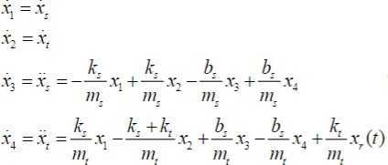

Than the state space equation is : -

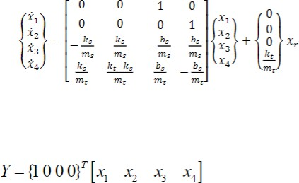

# Stability

The stability of a system can be thought as a continuity in its dynamic behavior. If a small perturbation arises in the system inputs or initial conditions, a stable system will present small modifications in its

perturbed response.

BIBO: a system is said to BIBO stable (bounded-input bounded output stable) if every bounded input excites a bounded output. This stability is defined for zero-state responses and is applicable only if a system is initially relaxed (assuming zero initial conditions).



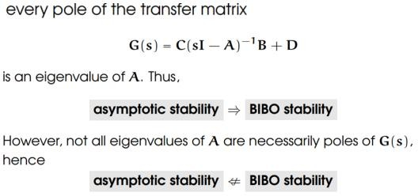

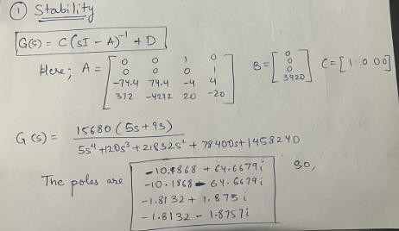

# Controllability

Controllability is the property that indicates if the behavior of a system can be controlled by acting on its inputs.

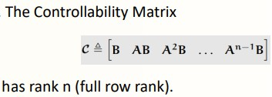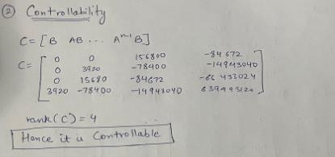

# Observability

Observability is the property that indicates if the internal behavior of a system can be detected at its outputs. The concept of observability is dual to that of controllability, and deals with the possibility of estimating the state of the system from the knowledge of its inputs and outputs.

Observability: The state equation above or the pair (A, C), is said to be observable if for any unknown initial state x(0), there exists a finite time

𝑡1 > 0 such that the knowledge of the input u(t) and the output y(t) over [0, 𝑡1 ] suffices to determine uniquely the initial state x(0). Otherwise, the equation is said to be unobservable.

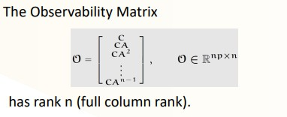

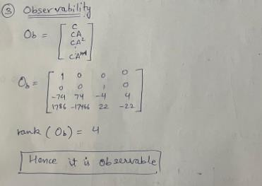

# Design a Feedback gain for a closed loop control

Recalling the system poles are the eigenvalues of A, matrix K is sought that can modify the input which will modify the eigenvalues that in turn will change the system´s behavior.



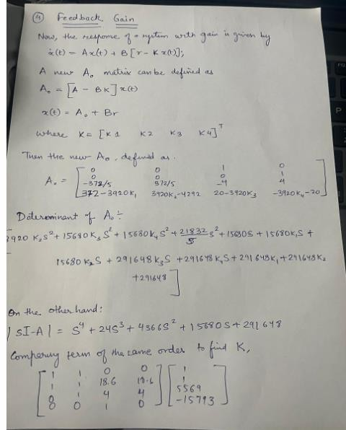

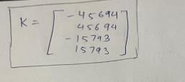

# CONCLUSION

A partition of a car was made in order to simplify the modelling. A disadvantage of doing so is that rotation between axis is ignored, which would introduce two extra degrees of freedom on the suspension. One rotation along connected wheels and more between front and rear axis. Further work ought to introduce such rotations in order to reproduce more accurately a car´s suspension. The proposed model reproduces the behavior of the selected problem modelled in time, state space, and frequency domain. Tests were performed to check the model´s stability, Gain, eigenvalues, roots, observability, and controllability; being all of them favorable.